**CardiacCare Abstraction Tips and Tricks**

# Overview

CardiacCare is an advanced system to allow complicated data abstraction to be performed more easily and efficiently. Here are a few tips and tricks to help abstractors in this process.

# Keyboard Shortcuts

While the entire form can be used with a combination of the mouse and keyboard, it is often more convenient to use keyboard shortcuts when working with fields. Here are several keyboard shortcuts which may be useful.

A data abstractor can navigate between fields using “Tab” on the keyboard.

For date fields, using “t” to quickly enter today’s date, or using the up and down arrows to adjust the date in the specified direction.

For numeric fields, using the up and down arrows to adjust the value in the specified direction.

For many fields, including Yes/No questions and single choice (drop-down) questions, the abstractor can select the desired value by pressing the first letter of the answer on the keyboard. For example, pressing “Y” on the keyboard would select the “Yes” answer of a Yes/No question. If a question has multiple answers which start with the same letter, the abstractor can either type the first few letters of the desired answer, or press the first letter of the answer multiple times to toggle through the options which start with that letter. For example, suppose a question had the answer choices: “Elective”, “Urgent”, Emergent”; and the abstractor wanted to select “Emergent”. The abstractor could either press “em” on the keyboard, or press “e” two times. (The first time “Elective” would be selected and the subsequent press would select the next answer starting with “e”, in this case the desired answer of “Emergent”.)

# Auto-Save

The save action occurs in the background automatically on a data form. A pencil icon appears at the top of a data form to indicate a save is in progress. An abstractor does not need to pause working while the save icon is displayed. It will disappear as soon as the save is complete. Saves occur for each field as soon as the data form can detect the field has changed. This means that even if the power were to go out, the most an abstractor might lose would be the last field entered.

# Finding a Field (Data Element)

Suppose that an abstractor needs to make a change to a data form, perhaps was provided information for a field initially not supplied by the surgeon. The abstractor knows that the field is somewhere on the data form, but cannot recall the exact location. As CardiacCare is a browser-based product, many of the build in features of a web-browser work. One such feature is the “Find on Page” feature. Press **Ctrl+F** and the find window will open.

The exact find/search interface presented will vary based on different web browsers (for example Microsoft Edge vs Google Chrome vs Mozilla Firefox), but all provide similar functionality. Here are a few screenshots:

*Microsoft Edge:*



*Google Chrome:*



*Mozilla Firefox:*



Type in some identifying feature of the field being sought. For example, the short name, the sequence (or element) number, or even a unique word in the long name (question description). The web browser will find and highlight all occurrences of the search phrase, and provide navigation between the search results, allowing the abstractor to quickly find the field/data element in question. Here is an example of a search for the term “Mitral”:

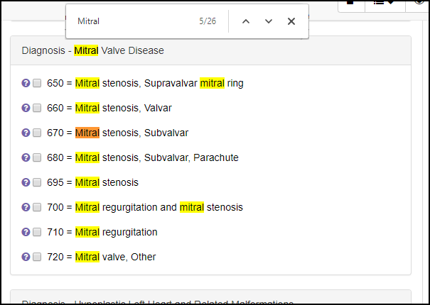

# Date vs Date/Time for Admission

Some registries will require a date and time entered for admission, while others will only require a date. As the registries vary, CardiacCare will accept both, but only require the date. If you are abstracting for a registry which requires both (for example ACC/NCDR CathPCI), be sure to enter the time component as well as the date.

# Surgery/Procedure Date

When creating a patient record in CardiacCare, there can be the question of what date to enter on the “Visit” screen. This date should be the date of the surgery/procedure. It will then automatically flow (populate) into any data forms associated with that visit folder, to the appropriate field.